Databases 2 – First Semester 2003
Exercise 2
30/10/03

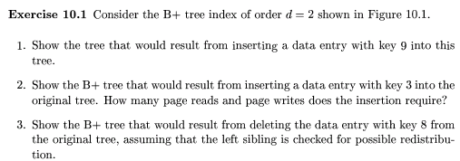
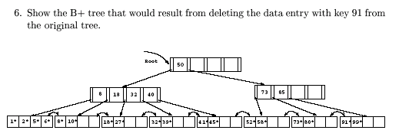

Problem 2.

Imagine that we had a B+-tree with n = 400, that is, each node can have up to 400 keys and 401 pointers.

- What is the maximum number of records that a three level B+-tree with n = 400 could index? What is the minimum number of records that a three level B+-tree with n = 400 could index, assuming no nodes were under-filled (according to the B+-tree rules)? By three level, we mean one leaf B+-tree level and two non-leaf levels.

- After many insertions, a B+-tree tends to reach a steady state where each node is about 70% full; in other words, each node has 0.7n keys in it, on average. Under the assumption that every node (including the root) is about 70% full, how many layers would an n=400 B+-tree be if it indexed 6 billion (6 x 10⁹) records?

- For the B+-tree of part (b), with n=400, 70% full nodes and indexing 6 billion records, what percentage of the total space consumed by the index is used by leaf-level blocks?

